Milestone report
MILESTONE: Alpha
TEAM NAME: Noflex
GAME NAME: Q
NAME: Minjae Kyung
JOBS: Product Manager
DEGREE PROGRAM: RTIS
GAME DESCRIPTION: Our game is a side view platformer rogue-like game. Player is an eminent scientist who participated in the space project.
LINKS: https://github.com/Rudy-Castan-DigiPen-Teaching/game-project-noflex

Work Done :

Multi-thread pool
  - Because of performance issues in debug mode, We have to increase performance.
  - Main reasons for decreased performance are the graphic engine on many objects and Ray-Casting for enemyAI.
  - Graphic engine is a structure problem and a graphic engine programmer is out of our team due to the military issue, so it cannot be fixed in the remaining days.
  - But Ray casting could be optimized. So a physics programmer worked hard to optimize ray casting but it is not enough to get performance.
  - So we decided to make a multi-thread.
  - First time, I tried to use std::async. It was not that very hard to implement it thanks to ECS and CHM is built by us and can be customized easily. It certainly improved performance a lot. but It does not look good because it is not on the engine but just on the system. So we don’t know which system we implemented a multi thread clearly. And we want more performance
  - So we decided to make a thread pool our own.
  - It was very hard to control the race condition. I thought I controlled all race conditions but it occurs a lot and I didn’t understand it.
  - And miscellaneous bugs bother me.
  - I finally found to control most of the race condition. Actually why this controls race conditions but it works. So I’m happy now.
  - If I have enough time during beta, I will support std::future thing.
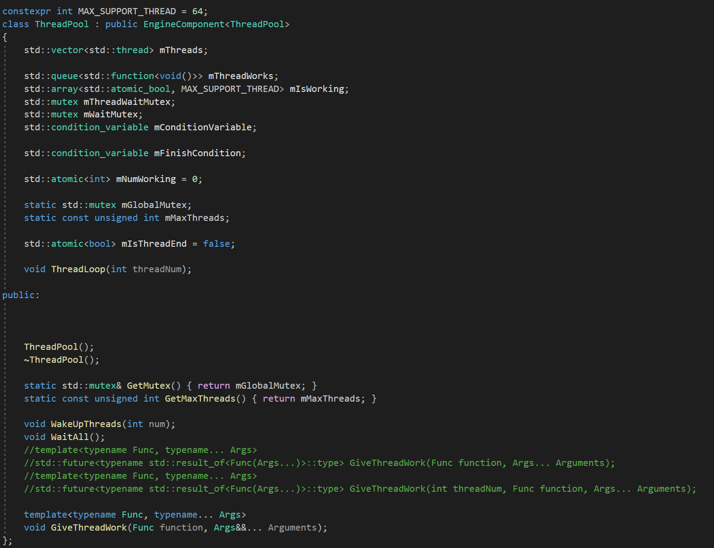

Boss AI
  - I make a simple boss AI.
  - Thanks to reconstructing AI stuff. It was not a very hard thing.
  - Main problem was sprite. We were very busy making a player’s sprite so there was not enough time to draw a new enemy sprite.
  - So I decided to reuse an already existing sprite.
  - But existing sprites are also not having enough motions.
  - So I decided to make bullet hell. It can reduce the lack of motions.
  - And it is not that weird that the boss that makes bullet hell can fly.
  - Thanks to that, I can use A* algorithm to chase the player.

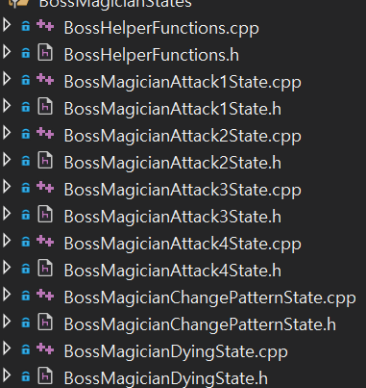
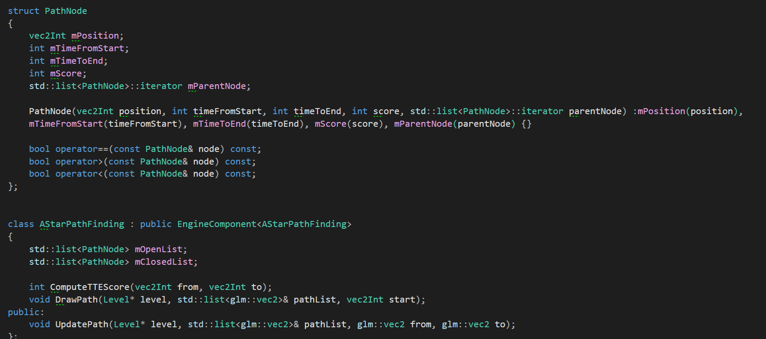

Notes :

